## Objectives:

* Use of Classes
* User of Methods
* Use of GUI (Graphical User Interface)
* Use of class inharitance

## Scenarios:

* 1. Expanding on the on the previous flag creation exercise, this exercise will use a color chooser dialog to set the components of the flag to different colors. Hence the ability to change the color of the flag to the flag of the countries below:
     + France
     + Belgium
     + Italy
     + Romania
     + Ireland

* A sample code for setting the color based on jSlider has been provided. Please expand on this code to provide a solution for the above exercise

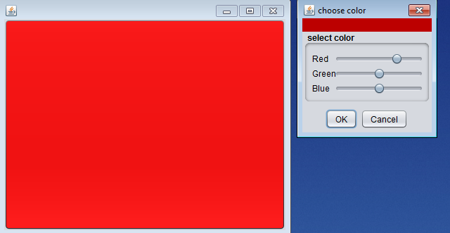

* The outcome of your solution should look like the one below. This represent the French flag

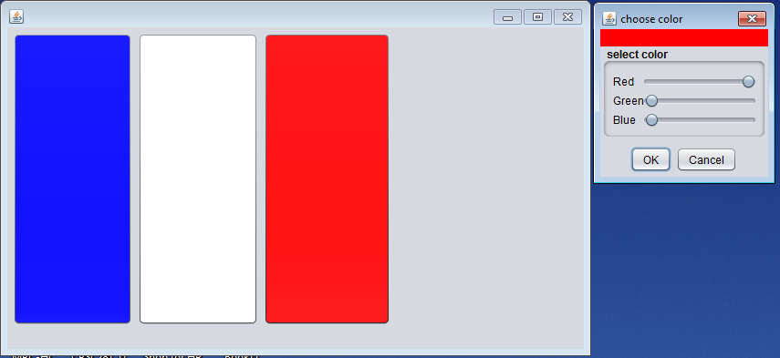

* 1. Expanding on the bank account class, create a graphical user interface that will allow the user to either deposit or withdraw money from the account and display the balance. You have the option to create your GUI from scratch or use the sample code provided and expand on it. Below is a representation of how the solution will look like:
* Open the solution to deposit $1000. Enter 1000 into the text field, then click deposit

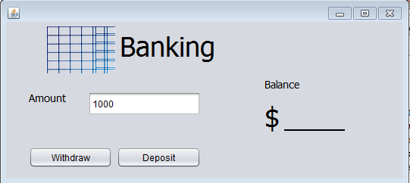

* Notice the balance change
* 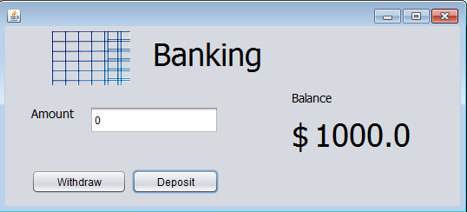
* Withdraw $350
* 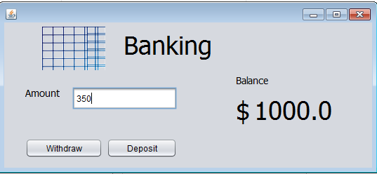
* Notice the balance change
* 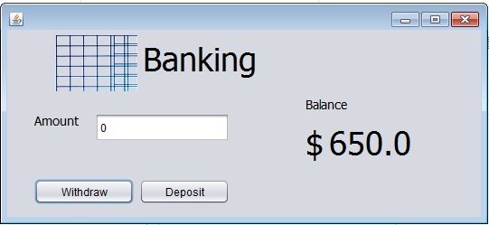
  1. Modify the BankAccount class previously created to add two methods: deposit and withdraw. These will be used to deposit of withdraw money from the bank account. Extend the BankAccount class to create two types of bank accounts: a checking account and a savings account. These will inherit the properties of bank account class, but have the following unique behavior:
     + When money get deposited into the savings account, an automatic 1% interest is added to the deposited amount
     + The savings account does not allow withdraw
     + When money get withdrawn from the checking account, a withdrawing fee of $1 is applied.

To test the functionalities of the BankAccount, CheckingAccount and SavingsAccount classes a class called BankTest will be created. This class will have a main method which will be used to:

* Create at least one instance of each bank account type, i.e BankAccount, CheckingAccount and SavingsAccount
* Deposit/withdraw money from these accounts
* Display (output) the balance and interest values from these accounts

## Grading:

* Scenario 1: 30pts
* Scenario 2: 40pts
* Scenario 3: 40pts

# Class ColorDialog

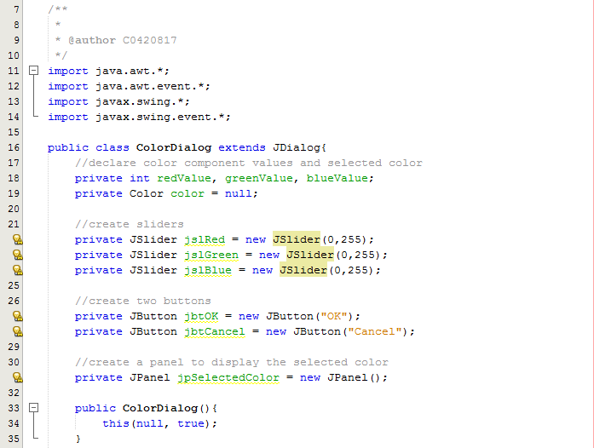

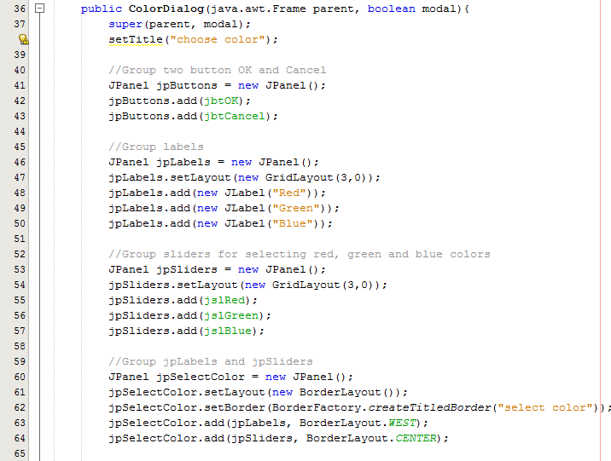

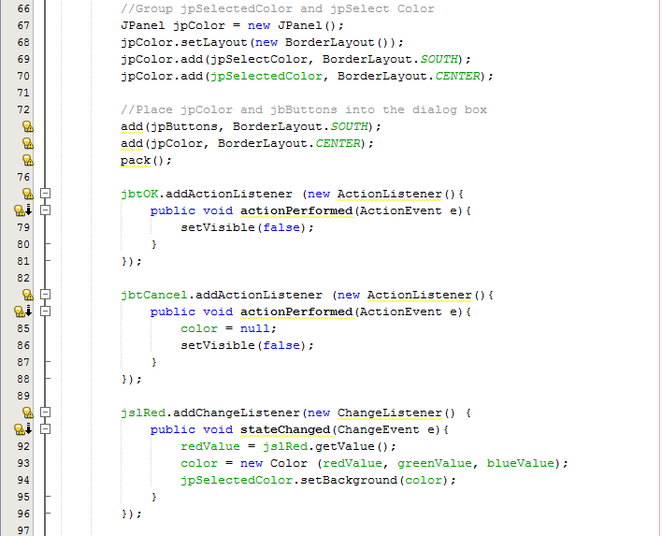

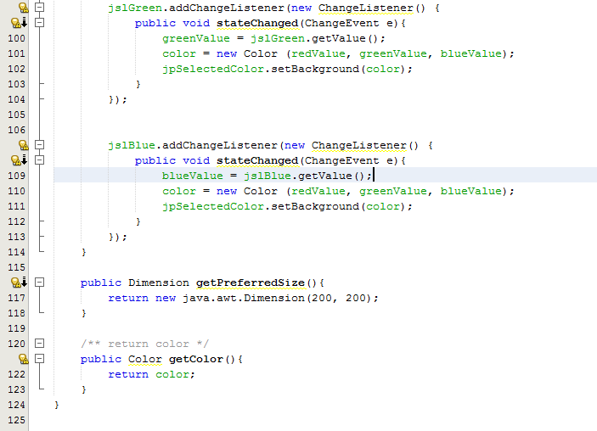

# Class Color_Frame (using ColorDialog)

